|  |
| --- |
| Boston University |
| ESME Workbench 2011 |
| User Guide |

|  |
| --- |
| Monday, 28 March 2011 |

Contents

Introduction 2

The One Navy Model 2

Transmission Loss Calculators 2

Marine Mammal Movement Models 2

The Team 2

The Purpose 2

The Purpose of This Document 2

ESME Workbench: User Interface Overview 3

The Ribbon Control 4

Configuration 4

Map Data 5

Overlays 5

Scenario 5

Environment 5

Sounds 5

Animals 5

Simulation 5

Reports 5

The Layer List 5

The Map 5

Workflow: Common Task Walkthroughs 6

Installation 6

Configuration 6

Building a Scenario 6

Loading a Scenario 6

Extracting Environmental Data 6

Determining Environmental Boundaries: Quick Looks 6

Calculating Transmission Losses: Analysis Points 6

Defining Animal Model Populations 6

Modeling Sound Exposure of Animals 6

Post-Processing Simulation Data 6

A Full Simulation: Flowchart 6

API 7

# Introduction

This document describes the purpose, use, and appearance of ESME Workbench 2011. This software product integrates components of the Naval Underseas Warfare Center (NUWC), Biomimetica, and associated models into the One Navy Model (ONM) to model the Effects of Sound on the Marine Environment (ESME).

## The One Navy Model

The ONM is a collection of discrete software products written by Biomimetica, BU, NUWC, and others. It does stuff.

### Transmission Loss Calculators

Bellhop

RAM

CASS

REFMS (?)

### Marine Mammal Movement Models

3MB

## The Team

BU, NUWC, Biomimetica, … ?

## The Purpose

Let’s be nicer to whales. They never hurt nobody.

## The Purpose of This Document

Everyone should know how to run a full simulation at some level. Let’s instruct them.

# ESME Workbench: User Interface Overview

ESME Workbench is intended to be an intuitive primary user interface to the ONM. From its main screen, users can complete all the steps necessary to run a full simulation, stopping and restarting at any point to modify parameters, view environmental information, or do any other task required before a simulation is fully run.

The Workbench Main Screen is pictured below:

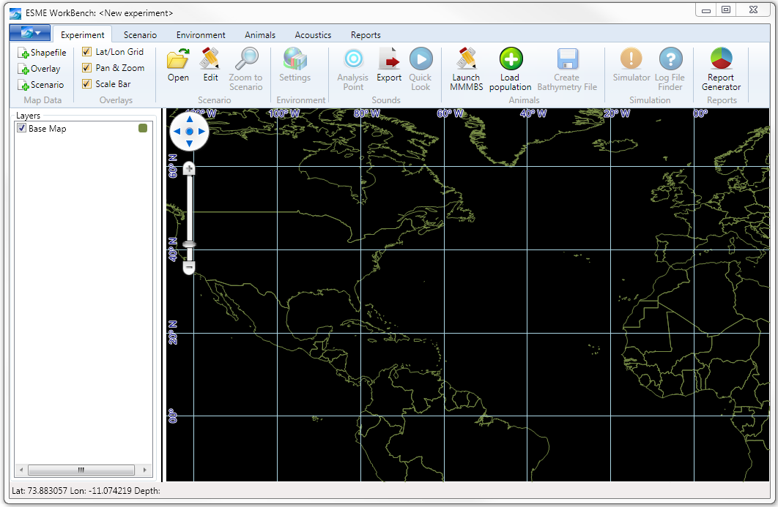

The Workbench has three main areas:

1. The **Ribbon Control**, highlighted in red, contains buttons and other tools to load, save, and configure experiment data. For example, Scenario Files can be loaded here.
2. The **Layer List**, highlighted in blue, contains a list of experiment data that is already loaded, and allows its manipulation. For example, Analysis Points, once created, can be manipulated here.
3. The **Map** , highlighted in green, contains a graphical display of data for users to make sense of their experiments.

Each area is described more fully in the following sections.

## The Ribbon Control

The ribbon control is the main way by which users add information to the experiment. There is a main application file menu, and several ribbon groups and tabs containing related buttons.

### Configuration

The large blue dropdown submenu is pictured below.

|  |  |
| --- | --- |
|  | |
| **Name** | **Function** |
| Recent Experiments | Lists recent experiments. Deleted or invalid experiments are not included. |
| Save Experiment | Opens a dialog box to save the experiment’s state to a .esme file. |
| Save Experiment As | Opens a dialog box to save a previously saved .esme file to a different name. |
| Open Experiment | Loads a previously saved .esme file and all associated metadata |
| Close Experiment | Unloads and removes all current experiment information. |
| New Experiment | Unloads and removes all current experiment information. |
| Info | Displays the build information about ESME Workbench and its libraries for bug-reporting purposes. |
| Options | Opens the global options dialog box, described later. |
| Help | Displays help information |
| Exit | Quits ESME Workbench |

### 

### Map Data

The Map Data ribbon group contains three buttons.

|  |  |  |
| --- | --- | --- |
|  | **Name** | **Function** |
| Shapefile | Opens a dialog box for the user to select a shapefile(*.shp) to load to the map display. |
| Overlay | Opens a dialog box for the user to select an overlay file (*.ovr) to load to the map display. |
| Scenario | Opens a dialog box for the user to select a scenario file (*.nemo) to load to the map display. |

### Overlays

The Overlays ribbon group contains three check boxes.

|  |  |  |
| --- | --- | --- |
|  | **Name** | **Function** |
| Lat/Lon Grid | Toggles visibility of the grid display on the map. |
| Pan & Zoom | Toggles visibility of the on-map pan and zoom control widget. Mouse pan/zoom is not affected. |
| Scale Bar | Toggles visibility of the scale bar |

### Scenario

The Scenario ribbon group contains three buttons.

|  |  |  |
| --- | --- | --- |
|  | **Name** | **Function** |
| Open | Duplicates the functionality of the Map Data Scenario button. |
| Edit | Launches the NUWC Scenario Builder for users to create new *.nemo files. |
| Zoom to Scenario | This button is disabled until a valid Scenario File is loaded. When a valid scenario exists, clicking this button orients and zooms the map display to show the entire operational area. |

### Environment

The Environment ribbon group contains one button.

|  |  |  |
| --- | --- | --- |
|  | **Name** | **Function** |
| Settings | Launches the Environmental Data Extraction Dialog, where users can select which time periods and which resolution OAML environmental data they wish to use for the experiment. |

### Sounds

The Sounds ribbon group contains three buttons.

|  |  |  |
| --- | --- | --- |
|  | **Name** | **Function** |
| Analysis Point | Launches the Analysis Point dialog box, which begins the process of defining and placing an analysis point on the map. This button is disabled until a saved experiment exists that has valid environmental data extracted. |
| Export | Generates CASSOMatic batch files for all analysis points on the map. |
| Quick Look | Launches the Quick Look dialog box, which begins the process of running a quick look. |

### Animals

The Animals ribbon group contains three buttons.

|  |  |  |
| --- | --- | --- |
|  | **Name** | **Function** |
| Launch MMMBS | Launches MMMBS for users to interact directly with animat seeding operations. |
| Load Population | Loads a previously seeded population of animals (*.spe) and displays them on the map. |
| Create Bathymetry File | MMMBS requires direct access to bathymetric information about the operational area. Clicking this button extracts the current experiment bathymetry for use by MMMBS. |

### Simulation

The Simulation ribbon group contains two buttons.

|  |  |  |
| --- | --- | --- |
|  | **Name** | **Function** |
| Simulator | Launches the NUWC Scenario Simulator. This button is disabled until all required steps for a simulation have been taken and all CASS transmission loss calculations have finished. |
| Log File Finder | Launches an explorer window to display the Scenario Simulator log file directory, for troubleshooting. |

### Reports

The Reports ribbon group contains one button.

|  |  |  |
| --- | --- | --- |
|  | **Name** | **Function** |
| Report Generator | Launches the NUWC Report Generator once the Scenario Simulator has completed a scenario simulation. |

## The Layer List

The layer list allows the user to control the display of information on the map. The layer’s visibility, display order, and where appropriate, symbol, color, size, and line weight may all be adjusted.

**Visibility**

Each layer in the layer list has a checkbox next to its name. Toggling the checked status of the box correspondingly toggles the visibility of that layer on the map. Note: unchecking a layer does not delete its associated data.

**Display Order**

Right-clicking on the layer’s name displays a Layer Order context menu.

## The Map

# Workflow: Common Task Walkthroughs

## Installation

## Configuration

## Building a Scenario

## Loading a Scenario

## Extracting Environmental Data

## Determining Environmental Boundaries: Quick Looks

## Calculating Transmission Losses: Analysis Points

## Defining Animal Model Populations

## Modeling Sound Exposure of Animals

## Post-Processing Simulation Data

## A Full Simulation: Flowchart

# API